C O N T E N T S

CHAPTER 1: INTRODUCTION Page No.

1.1 Introduction about the Company
1.2 Problem Statement
1.3 Proposed Solution
1.4 Deliverables

CHAPTER 2: PROJECT DESCRIPTION

2.1 System Interfaces
2.2 System Specifications
2.2.1 H/W Requirement
2.2.2 S/W Requirement
2.3 Methodology and Tools used
2.3.1 Requirement Phase
2.3.2 Design Phase
2.3.3 Development Phase
2.3.4 Implementation Phase
2.3.5 Testing Phase
2.3.6 Post Implementation Maintenance
2.4 Constraints
2.5 Assumptions & Dependencies
2.6 User Characteristics

CHAPTER 3: FUNCTIONALITY

3.1 Logical Database Design
3.1.1 ERD
3.1.2 Table Structures
3.2 Input Design (1…..n)
3.2.1 Layout (name & reference no.)
3.2.2 Purpose
3.2.3 Description of each field
3.2.4 Validation Checks
3.3 Output Design (1…..n)
3.3.1 Layout (name & reference no.)
3.3.2 Purpose
3.3.3 Description of each field

3.4 Use case Description (1…n)
3.4.1 Use Case Diagrams
3.4.2 Use case Description

CHAPTER 4: TESTING

4.1 Test Activities (with details)
4.2 Unit Testing
4.2.1 Methodology Used
4.2.2 Tools Used
4.2.3 Test Cases
4.3 Integration Testing
4.3.1 Methodology Used
4.3.2 Tools Used
4.3.3 Test Cases
4.4 System Testing
4.4.1 Functional Testing
4.4.1.1 Methodology Used
4.4.1.2 Tools Used
4.4.1.3 Test Cases
4.4.2 Non-Functional Testing
4.4.2.1 Methodology Used
4.4.2.2 Tools Used
4.4.2.3 Test Cases
4.5 Test Reports and Debugging
4.6 Implementation

CHAPTER 5: CONCLUSION AND REFERENCES

5.1 Conclusion
5.2 Limitations of the System
5.3 Future Scope for Modification
5.4 References

CHAPTER 6: ANNEXURES
A-1 Table Structures
A-2 Project Architecture
A-3 Design Diagrams
A-4 Data Flow Diagrams
A-5 Decision Table/Tree
A-6 Input Output Design Layout
A-7 List of figures and tables

CHAPTER 1
INTRODUCTION
1.1 Introduction about the Company
1.2 Problem Statement
1.3 Proposed Solution
1.4 Deliverables

1.1 Introduction
1.1.1 About Nagarro Software Pvt. Ltd.
Nagarro provides technology services that address the complex business needs of its clients. Through a unique combination of domain knowledge and engineering expertise, Nagarro helps meet the strategic goals of companies ranging from early stage ventures to Global 1000 market leaders. Navarro’s proven methodology combines specialized technical skills with Projistic, a proprietary project management tool, to ensure quality, security and control in distributed development environments.

Some of the world‘s well-known and popular software products include parts from Nagarro. These range from enterprise software and infrastructure software to shrink wrapped consumer software. With Navarro’s flexible offshore software development model, these ISVs routinely create more with less.
Nagarro is a Microsoft Gold Certified Partner and has equal numbers of resources in Microsoft and Java technologies. References from our ISV customers are available on request.
Company Facts
- Founded in 1996
- Headquartered in San Jose, California with offices in New York, Chicago, Mexico, India, Sweden and Germany
Awards -
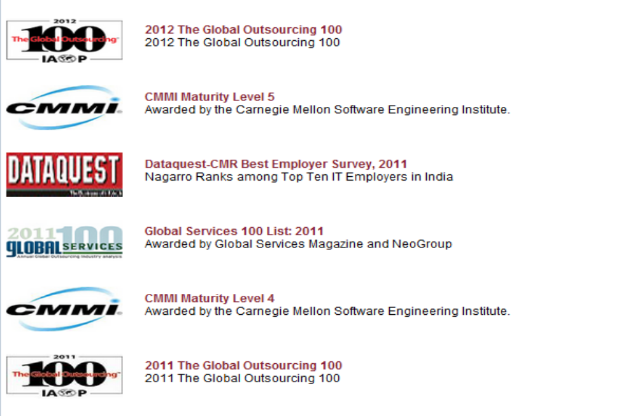
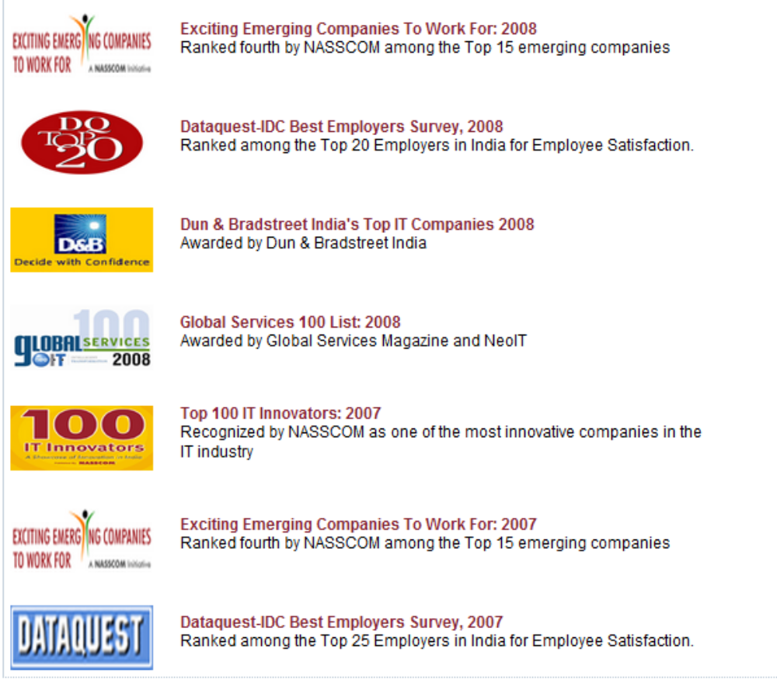

1.1.2 Software Services - Process and Methodology
Application Development
Nagarro provides outsourced software development services for in-house applications, across the project lifecycle. Nagarro partners with client from internal proposals and budgeting, through project approvals, all the way to delivery, training, maintenance (including porting where required) and support. The flexible offshore software development model allows companies to maximize their ROI, while maintaining complete control over projects. In Navarro’s experience, outsourcing software development projects successfully requires frequent communication and adherence to processes. Projistics, Navarro’s proprietary online project management tool, enables client, onsite teams and overseas teams to communicate and manage projects seamlessly, ensuring visibility, security and quality. Projistics allows clients to leverage flexible team size and cost-efficiency through Navarro’s distributed development without increased risks.
Product Engineering
The software products industry depends on bringing new concepts, new versions and new features to the market quickly. At the same time, development costs must be low, predictable, and ideally even flexible. Nagarro brings key differentiators to product development for ISVs:
- Excellent hiring and employee retention methods to assemble for you the best architects and engineers, a must for challenging software product engineering projects
- World-class product-specific developer training material that is created in-house for each ISV client
- Flexible onsite + offshore product development teams that maximize client ROI
- Online development management tool Projistics that facilitates security, control and quality in distributed development environments, common in offshore software development
Testing Quality and assurance
Using its Quality Assurance approach, Nagarro has successfully serviced Global 100 companies with stringent compliance requirements for FDA- and FAA- mandated verification and validation. With its SEI CMMI Maturity Level 5 certification, Nagarro has implemented a planned and systematic approach to the adherence to software product standards, processes and procedures and to the evaluation of quality. Nagarro has defined internal standards for documentation, design and code. Procedures have been defined for activities such as configuration management, nonconformance reporting and corrective action, testing, code walkthroughs and formal project inspections. In addition, a system of audits has been instituted for process monitoring.
Navarro’s software testing primarily verifies correctness, completeness, security and quality. Nagarro testing approach begins with unit tests created by our developers that are later integrated into the regression tests. Our dedicated testers design test cases and suites, perform automated and manual tests as per the test suites, and document results appropriately
1.2 Problem Statement
The main objective of Flight Search Web Application is to provide suitable environment and facilities for various business needs to users. Present state of the application do not require members to be registered through Internet. Nor the old members can themselves search for flights. Also it is very difficult to keep track of the various flights flying on a particular time and to add new data. They need to keep the request manually by calling the Flight Search operator.
Need of Computerization
Currently, users who need services for searching flight have to do manually and employees are solely responsible for correctness of the system. It also requires more staff to reach users for their enquiries. Computerized process also increases the Marketing staff reaching the clients for their bookings and enquiries. And the current process is not flexible enough to adopt the changes as per the requirement of time.
1.3 Proposed Solution
This project, carried out at Nagarro, is basically a ― Flight Search Web Application for all the users looking to fly between two locations on a particular date and time. The users consist of various employees of client Company. For this project following modules have been developed by us:-
- User Authorization.
- User Registration.
- Flight Import.
- Flight Management.
- Search.
- Logging
For the purpose users are divided as:
- Client User: Users who are using the services of the system. Their possible actions are
- Login to the application
- Search for flights
- View various search results
- Admin User: Users who are responsible for keeping track of services to be provided to the clients. Their possible actions are
- View all Users Information
- Manage flights
- Upload flight data
- Search
- View search results
- Manage configuration Details

1.4 Deliverables
We have introduced Flight Search System to make the work operational through internet. This solution will not only improve the user experience but cut short various marketing costs. The users can track the status of any flight and make new entries and requests for searching available flights from their own sites.
This application is used for management of the flight details by storing it in a centralised location rather than maintaining several files. This application is to be used for online search of the flights, managing the flight data etc. Thus, the application can be divided into various modules and sub modules.
The application has four main modules:
- User Registration
- Login
- User requests for search
- Admin

As part of documentation following are delivered –
S. No | Phase | Deliverable | Page No.
 | Requirement Analysis | Strategy Document | 10
 | Design | Strategy Document | 14
 | Unit Testing | Test Cases & Test Result | add page numbers
 | Integration Testing | Test Cases & Test Result | -
 | System Acceptance testing | Complete operational System | -
 | User Acceptance Testing | Validation of system by users of the system | -

CHAPTER 2
PROJECT DESCRIPTION
2.1 System Interfaces
2.2 System Specifications
2.2.1 H/W Requirement
2.2.2 S/W Requirement
2.3 Methodology and Tools used
2.3.1 Requirement Phase
2.3.2 Design Phase
2.3.3 Development Phase
2.3.4 Implementation Phase
2.3.5 Testing Phase
2.4 Constraints
2.5 Assumptions & Dependencies
2.6 User Characteristics

2.1 System Interfaces
The system is developed by layered approach. Basically it contains these layers Database, Data Access Layer (DAL), Business Logic Layer (BLL) and User Interface Layer (UI).
The Database used in this Application is MySQL which is an open source Database. The Data Access Layer (DAL), provides the interface to the Business Logic Layer (BLL) and the Database. This layer will handle all the database activity. The Hibernate Framework implements this layer. ―Hibernate‖ is an ORM (Object Relational Model) tool. The database is accessed using the Persistent classes called as POJO‘s.
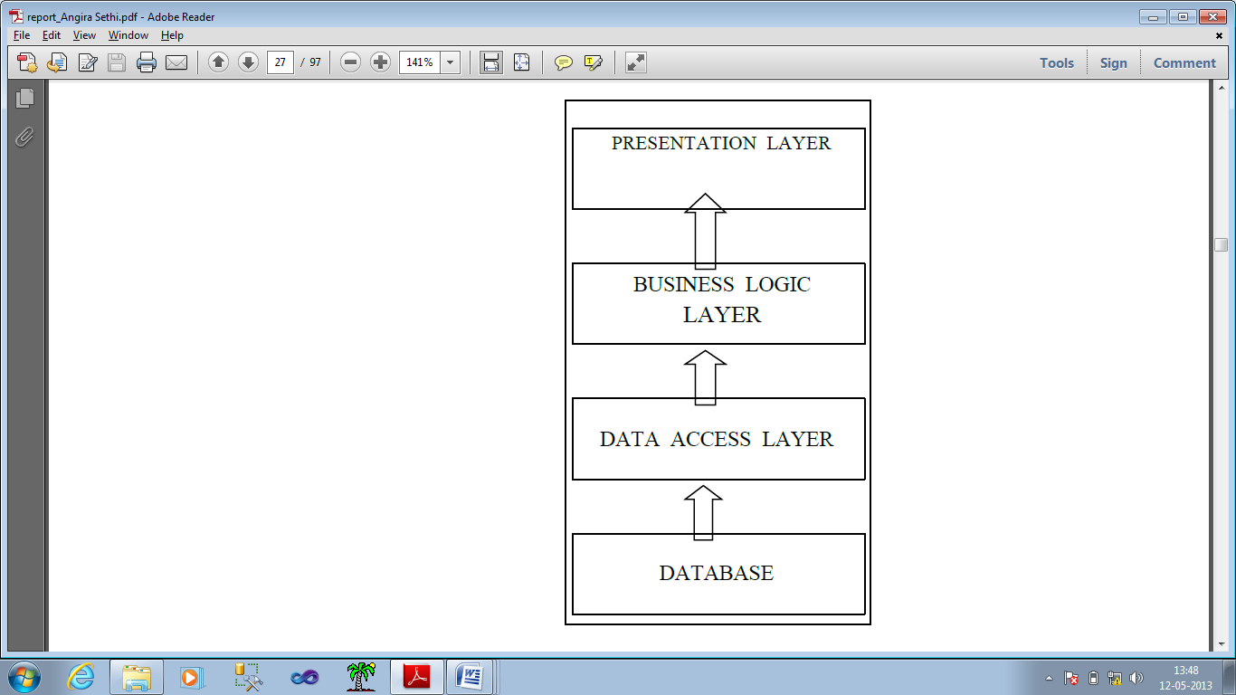
Fig 1.1 Architecture
The Business Logic Layer (BLL) provides all the business logic to implement the system. It contains the core functionalities of the system. It also provides the Code Behind pages (Code behind Page contains the programming logic of the UI Layer) and for binding the layers spring web mvc (model-view- controller) framework is used.
The UI Layer provides the interface between user and the system. This layer contains all the web pages and forms shown to the user as well as via these pages the user can interact with the system. These pages are developed using jsp‘s and spring tag library. It interacts with other layers to accomplish the application specific task.

- USER INTERFACES
The application will have a user-friendly and menu based interface. Following screens will be provided. Access to different screens will be based upon the role of the user.
- The User Registration provides the interface to the user through which s/he can register (if new user) [Ref. Annexure A-5 Fig 10]
- The Registration Confirmation is responsible for showing details entered by user before making them final [Ref. Fig Annexure A-5 11]
- The Forgot Password provides user a way to retrieve credentials if not remembered [Ref. Fig Annexure A-5 12]
- The User Login page is responsible for making one possible to access the pages available to the user [Ref. Annexure A-5 Fig 9]
- The Admin Home Page gives admin a way to control the flow for him/her. [Ref. Annexure A-5 Fig 13]
- Manage Flights tab will enable admin to edit and delete a flight entry
- Upload tab will enable admin to upload various files statically or dynamically.. [Ref. Annexure A-5 Fig 15]
- Configure tab will enable admin to manage the configuration properties of the application and edit it thus providing extensibility and flexibility to the application

  - System Specification
2.2.1 H/W Requirement

Since the software platform is based on Java, the hardware platform can be anything that supports a recent JVM.
HARDWARE | SPECIFICATIONS
CPU | Intel Pentium-4 (or compatible)
CLOCK SPPED | 600 MHz
RAM | 1 GB
HARD DISK | 10 GB
Table 2.1 Hardware Requirement

2.2.2 S/W Requirement

 | Module | Version
Operating System | Microsoft Windows | 7.2  XP (Pro.)
Database | MYSQL | 5.5
Java | SDK/JRE | 1.7  or higher
Source Repository | SVN | 1.7.3
Web Server | Apache Tomcat | 7.0.42
Servlet Engine | Tomcat Standalone | 7.0.42
IDE | Eclipse Kepler | 4
Object Relational Mapping | Hibernate | 4.2.4
Framework | Spring | 4.0.0
Logger | SLF4j with Log4j as backend | 1.7.6
Fig 2.2 Software Requirement

The clients would need to be configured for the support of following software
 | Module | Version
Browser | Mozilla Firefox , Chrome | Latest recommended

Fig 2.3 Client Configuration

2.3 Methodology and Tools Used
Methodology Used
The concerned Project uses Agile methodology of iterative development where requirements and solutions evolve through collaboration between self-organizing cross functional teams.
Agile web development is a model for development of web applications. It is more efficient and powerful within a shorter timeline than other models and incorporates face-to-face communication, and includes technical personnel as well as customers as part of the team. Agile web development uses project managers, business analysts, emphases on clear goals, planning, and iterative delivery. Agile web development ensures the successful completion of product at the end of each iteration.

Architecture Used
Three Tier Architecture used with defined Layers
Layered architecture focuses on the grouping of related functionality within an application into distinct layers that are stacked vertically on top of each other. Functionality within each layer is related by a common role or responsibility.
Presentation Layer
This is the topmost level of the application. This layer contains the user oriented functionality responsible for managing user interaction. In the project this layer is implemented with help of java server pages (jsp) including spring tags to bind with back-end layers [Ref. Annexure A-6 Fig 19 & 21]. UI layer interacts with controller classes in layered architecture of project.
Business Logical Layer
This layer implements the core functionality of the system, and encapsulates the relevant business logic. It generally consists of components, some of which may expose service interfaces that other callers can use. Controller layer of project as mentioned previously communicates to layer named as ‘Manager’ classes in project hierarchy. [Ref. Annexure A-6 Fig 19 & 21]
Data Access Layer
This layer provides access to data hosted within the boundaries of the system. The data layer exposes generic interfaces that the components in the business layer can consume. In the project this layer is implemented with help of hibernate where the interaction with database is done with help of pojo’s defined and xml files defined to the references.

    - Requirement Phase
- Use Case Model: Use case models enable you to explore how users will work with your system. Use cases are been defined of different work scenarios under this model. In project use case model is fully defined in section 3.3can be seen in fig 20 & 22 in Annexure A-6
- Initial Domain Model: This defines the fundamental business entities and relationship between them. The way classes are interacting to provide the functionality and
- Website Structure Model: Website Structure Diagram has been defined which shows the overall structure of the applications and lists all the screens that can be accessed by the users. This tells how layers are packaged in the project and can be seen in Fig 1 & 2 of Annexure A-1

Requirements
- Functional Requirements
- All users must login with their user name and password.
- Role Based Security Needed: Admin and User
- Administrator manages flight records and related activities
- User can register himself/herself on site
- User can search for flights.

2.3.2 Design Phase
Agile Design Model is followed with a Test Driven Design Philosophy. Under this model Unit testing is performed along with Design and development of functional units in parallel. The first step is to quickly add a test, basically just enough code to fail. Next new tests are run to ensure their failure. You then update your functional code to make it pass the new tests. The fourth step is to run tests again. If they fail we update functional code and retest. Once the tests pass the next step is to start over with a new test.
Design phase commences after the requirements finalised and frozen. The design phase attempts to uncover various entities involved in the system and their associated behaviour and also the interfaces that would be provided by the system. ER Diagram and data flow diagrams for the systems are developed. Database tables and relationship between them is also defined. Refer Annexure A-3

2.3.3 Development Phase
The System is developed as 3 tier architecture with bottom up strategy defined as follows:
- Data Access Layer: - A data context is defined on this layer which manages connections to the Tables in Data Base. For accessing the data hibernate is used, it provides object relational mapping and an easy way to access the database. And if we want to extend our database with requirements then changes to be made to use that would be minimal and would not affect the already existing code.
- Business Logic Layer: - This layer acts as a bridge between interface layer and the Data Access Layer. All Business and Modification logic has been applied under this layer. Over here API’s are defined so as to access data from DAL and restructure it so that it can be used in presentation layer. This layer has a defined framework with following Classes:
- Business Objects Class: - This class defines functions which return generic Business objects. These objects are just for use and non-modifiable. For example return of Flight Details for a specific flight w.r.t. a particular user.
- Edit Object Class: - This class defines the functions which perform the modification on objects sent to them. Modifications include updation, deletion and addition of records. E.g., FlightManager class is responsible for editing the contents of Flight in the system and use them according to need.
- Business Objects List: - The class defines all the functions which return not-editable lists of business objects. E.g., Data Transfer Objects are used for the purpose.

- Presentation Layer: This layer defines generic interface with which user interacts. It is as classes which define functions for presentation of data retrieved from business access layer to user. This is implemented with help of jsp’s. And for presenting the layout main emphasis is given on spring tag library.

Tools Used
- Eclipse
Eclipse is a multi-language Integrated development environment (IDE) comprising a base workspace and an extensible plug-in system for customizing the environment.
- MySQL
MySQL the world's most widely used open source relational database management system (RDBMS) that runs as a server providing multi-user access to a number of databases.

2.3.4 Implementation Phase
The System is implemented on tomcat server. The data base is maintained under MYSQL. User Interacts via a web browser which sends HTTP request to the server which replies back after processing the requested page. Thus the system is implemented as a Client-Server model. To access the data the application connects to the server which replies with requested Data Sets. And on a whole the way the workflow is maintained can be seen in Annexure 7 Figure 19 & 21
2.3.5 Testing Phase
Bottom up testing was performed on deliverable of the project starting from Business Access Layer
Unit Testing
Unit testing at Data Access Layer was performed on the Procedures before being added to context to check their direct working on Databases. At Business Logic Layer Unit Testing was performed on Various Business and Edit Objects using Drivers at Interface Layer to test the retrieval and accuracy of data at the data Access Layer
Integration Testing
Integration testing within the deliverable involved integrating all the layers and to check the secure flow of Information under the defined roles defined. Integrity checks were tested on the Data Passed to the Data Access Layer from the User Interface Layer.
System Testing
System Testing was performed under the deployment environment to check for acceptance under Environment.

  - Constraints
- Display of content varies from Browser to Browser it is recommended to use Chrome or Mozilla Firefox or similar browsers to view the site perfectly.
- The admin has to update various flights manually i.e., decisions regarding the flights fields is still manual and can be automated which will further increase performance.
- Testing process is carried out on a limited number of hosts

  - Assumptions and dependencies
1. The Administrator or any admin person must have a pre-allotted Usernames.
2. There is no Upper Limit on Number of searching.

  - User Characteristics
No special technical expertise required by the user. Users should be comfortable using internet on a computer

CHAPTER 3
FUNCTIONALITY

3.1 Logical Database Design
3.1.1 ERD
3.1.2 Table Structures
3.2 Input Design (1…..n)
3.2.1 Layout
3.2.2 Purpose
3.2.3 Description of each field
3.2.4 Validation Checks
3.3 Output Design (1…..n)
3.3.1 Layout (name & reference no.)
3.3.2 Purpose
3.3.3 Description of each field

3.4 Use case Description (1…n)
3.4.1 Use Case Diagrams
3.4.2 Use case Description
3.1 Logical Database Design
3.1.1 ERD (Refer to Annexure A-3 Figure 4)

3.1.2 Table Structures
1) User (Refer to annexure A-1 Table 3.1)
User table is responsible for holding user details. Used to contact the users and for saving their credentials.
2) Flight (Refer to annexure A-1 Table 3.2)
Flight table is used to save details regarding the flights. This is used for searching.
- History(Refer to annexure A-1 Table 3.3)
History table is used to store the history of the uploaded files.
- Role (Refer to annexure A-1 Table 3.4)
Role table is used to store roles of users.

3.2 Input and Output Design
3.2.1 Layout
User
Register
Login
Search for flight
View Results
Forgot Password
Admin
Login
Edit Flight
Delete Flight
Upload File statically or dynamically
Manage configuration information

3.2.2 Purpose
Register (Ref. Annexure A-5 Fig 10)
Used to register on the site so as to raise the requests
Login (Ref. Annexure A-5 Fig 9)
Enables the user/admin to log in to the system. User would be shown the pages for which he/she is authorized.
Forgot Password (Ref. Annexure A-5 Fig 12)
Enables the user to enter email id so as to get the password. User gets credentials so as to log in to the system.
Manage Flight (Ref. Annexure A-5 Fig 14)
Enables the admin to edit or delete flight details
Upload (Ref. Annexure A-5 Fig 15)
Enables the admin to upload statically or dynamically different files. The files may be csv, excel, word and can be uploaded via http or ftp protocol. It also shows the upload history.
Configuration
Enables the admin to manage the configuration details making the application extensible.

3.2.3 Description of Each Field
Register
- First Name : first name of the user
- Last Name : last name of the user
- Email: email id of user
- Similarly the other details of the user
- Submit button to register the user
Login
- User Name : user name assigned to user is entered
- Password : password assigned to user is entered
- Submit Button : Enables the user to log in to the system
- Link for registration(“Register now”) : Redirects to registration page
- Link(“Forgot Password”) : Enables to forgot password screen

Forgot Password
- Field for entering email-id where credentials are to be sent
- Submit button to redirect to login page and getting credentials

Manage Flights
- Options to edit that takes to edit form, and delete that opens up a tabular data to get values to be deleted
- Edit link: Display form to contain flight data to be edited. Save button saves the edited data and cancel returns to previous page.
- Delete button opens up a form to get values from the user to be deleted. It contains two buttons. Delete button deleted the entry from database and cancel button clears out form entries.
Upload
It contains four tabs:
- Configuration: stores the configuration details for the application
- Static import: import csv, excel, word, xml files and ass data to database.
- Dynamic Import: Import file via http or ftp
- History: Contains the history of uploaded files

3.4 Use Case Description
3.4.1 Use Case Diagrams (Refer Figure no 3)
No. Of Actors: 2
No. Of Use Cases: 6
Use Cases associated with user: Login
Search Flight
Registration
View Flights
Logout
Use Cases associated with admin: Login
Manage flights
Upload Files
Manage configuration
Logout
3.4.2 Use Case Description

Use Case1 | Login
Introduction | This use case describes how a person logs into the system.
Actors | Admin, user
Pre-Conditions | All actors must have a user account (i.e. Username and password and role) created for them in the system through registration, prior to executing the use case.
Post Conditions | If the use case was successful, the actor is logged into the system. If not, the system state is unchanged.  If the actor has the role of ―Admin, he/she would have access to the screens involving all the submitted and other ticket requests.  If the actor has the role of ―User, he/she will have access to the new ticket request window.
Basic Flow | a) The system requests the actor to enter his/her username and password. The role can be any one of the admin and the user.  b) The actor enters his/her username and password.  c) The system validates the entered name and password and logs in the actor into the system.
Alternate Flow | a.) Invalid name/password  If in the basic flow, the actor enters an invalid name, password the system displays an error message. The actor can choose to either return to the beginning of the basic flow or cancel the login, at which point the use case ends.
Special Requirements | None
Extension Point | None

Table 3.4 Use Case1 Description (Login)

Use Case2 | Registration
Introduction | This use case describes how a new user registers into the system.
Actors | User
Pre-Conditions | The user must be an employee of the client company.
Post Conditions | If the use case was successful, the actor is registered to the system and a mail is generated that sends username and password to the user email address. If not, the system state is unchanged.
Basic Flow | a) The user clicks on ―Register  b) The system requests the actor to enter his/her personal details i.e. name, address, city, state, country, telephone, Email Id.  c) The actor enters his/her details.  d) The system validates the entered details and registers the actor into the system.  e) The system generates an Email sending the username and password to the user.
Alternate Flow | If in the basic flow, the actor does not enter a particular user detail, system displays an error message. The actor can choose to either return to the beginning of the basic flow or cancel the registration, at which point the use case ends.
Special Requirements | None
Extension Point | None

Table 3.5 Use Case2 Description (Registration)

Use Case3 | Search
Introduction | This use case describes how user can search for a flight
Actors | Admin, General User
Pre-Conditions | The Actor must have a valid username and password and must be logged into the system.
Post Conditions | If the use case was successful, the actor is successful in viewing the results of the search made by him/her
Basic Flow | a.) The actor clicks on ―Search tab on the Home page  b.) The system shows the search page  c.) The actor enters required inputs in the provided area  d.)The actor clicks on the Search Button.  e.)The application performs the searching.  f.)The application displays the result to the actor.
Alternate Flow | If in the basic flow, the actor clicks on the ―Admin Home‖ button before clicking search button, the search will not be performed.  If the actor clicks on the Cancel button, the search will not be performed.
Special Requirements | None
Extension Point | None

Table 3.6 Use Case3 Description (search)

Use Case4 | Import files
Introduction | This use case describes how an admin can upload flight details in the system.
Actors | Admin
Pre-Conditions | The Actor must have a valid username and password and must be logged into the system.
Post Conditions | If the use case was successful, the actor is successful in uploading the flight details.
Basic Flow | a) The admin clicks on Upload.  b) The system opens upload page.  c) Actor can perform the following actions on this page:  1.Change settings for upload  The actor can change the settings of the various options for upload and clicks save button.  2.Select manually  The actor has 2 options after this:  -upload using file:the actor selects a file from the system and clicks upload  -upload manually: the actor enters input one by one to the flight details.  3.Select dynamically  The actor can upload a directory of files on the server, and application will pick files from there  4.Selects history  The actor clicks on the history button to view the history of uploaded files
Alternate Flow | If the actor at any point of stage clicks Cancel button, the use case will end there
Extension Point | None
Table 3.7 Use Case4 Description (Upload file)

Use Case5 | Manage flights
Introduction | This use case describes how an admin edit or delete a flight entry from database
Actors | Admin
Pre-Conditions | The Actor must have a valid username and password and must be logged into the system.
Post Conditions | If the use case was successful, flight data is updated
Basic Flow | a) The admin clicks on Manage flights tab.  b) The system opens manage flights page.  c) Actor can perform the following actions on this page:  1.Edit a flight entry  It takes the user to edit flight form where the actor can edit the details of a particular flight.  2. Delete Flight entry  Actor can delete the entry of a flight by providing in necessary input
Alternate Flow | If the actor at any point of stage clicks Cancel button, the use case will end there
Extension Point | None
Table 3.8 Use Case5 Description (Manage Flights)

Use Case6 | Display Results
Introduction | This use case displays the search result for flights.
Actors | Admin, user
Pre-Conditions | The Actor must have a valid username and password and must be logged into the system.  Actor must have provided in the valid details to search for a flight and clicked on submit button
Post Conditions | If the use case was successful, the list of available flights is displayed to user
Basic Flow | a) The actor clicks on Search tab.  b) The system opens search page.  c) Actor provides the required input and submits the form.  d)List of flights is displayed
Alternate Flow | If the actor at any point of stage clicks Cancel button, the use case will end there
Extension Point | None
Table 3.9 Use Case6 Description (Display Result)

Use Case7 | Logout
Introduction | This use case describes how a person logs out of the system.
Actors | Admin, user
Pre-Conditions | Actor must be logged in to the system
Post Conditions | If the use case was successful, the actor is logged out of the system. If not, the system state is unchanged.
Basic Flow | a) User clicks on the logout button  b) System invalidated the session and direct user to login page
Alternate Flow | a.) Could not logout  If the system does not invalidate the session, it is invalidated automatically after few minutes of inactivity
Special Requirements | None
Extension Point | None
Table 3.8 Use Case7 Description (Logout)

CHAPTER 4
TESTING
4.1 Test Activities
4.2 Unit Testing
4.2.1 Methodology Used
4.2.2 Tools Used
4.2.3 Test Cases
4.3 Integration Testing
4.3.1 Methodology Used
4.3.2 Tools Used
4.3.3 Test Cases
4.4 System Testing
4.4.1 Functional Testing
4.4.1.1 Methodology Used
4.4.1.2 Tools Used
4.4.1.3 Test Cases
4.4.2 Non-Functional Testing
4.4.2.1 Methodology Used
4.4.2.2 Tools Used
4.4.2.3 Test Cases
4.5 Test Reports and Debugging
4.6 Implementation

4.1 Testing Activities
- Project Initiation: Testing Targets were set during this phase. From the point of view of testing the main tasks were to organize the approach towards testing. As we had not used tools for testing application was deployed on server and every possible scenario working was looked for manually so as to look for every possible effect.

- Development team Testing: In this strategy testing was done by us only for all the targets for the test cases defined later in this chapter.

- End-of-lifecycle Testing: As part of end of lifecycle testing the application was given to peers to test for all the test cases decided.

4.2 Unit Testing
4.2.1 Methodology Used
Unit testing is carried out by the developer in the developer environment only. Manual testing was done. The developers reviewed code to check whether our respective units under tests behave as expected.
4.2.2 Tools Used
Not Applicable. Manual testing was done.
4.2.3 Test Cases
Test Id | Test Case Name | Test Case Description | Expected Output
1 | Return valid search entries | Correct flight details should be presented by the user for search operation | Valid search details
2 | Error on invalid input details for searching | Error should be given if wrong data is passed | -1
3 | Return valid flight list when form is submitted | Correct list of flights should be returned sorted based on user’s preference | List of all flights returned
4 | Return valid flight list when form is submitted | Correct list of flights should be returned | List of flights returned
5 | Submit Fare Sort | List should be sorted based on fare of flight | List sorted based on submit fare
6 | Fare and duration Sort | List should be sorted based on fare and duration of flight | List sorted based on requester parameter
7 | Error on invalid input type | Error message given if invalid set of data are requested | -1
8 | Login | User is able to login to the system using credentials | User logged in system
9 | Error on Login | User gets error message on wrong credentials | -1
10 | Register | User should be able to register on system | User registered
11 | Mail for registration | Mail is to be delivered from system after registration | e-mail sent to user with details
13 | Forgot Password | User is delivered with details if password is not remembered | Password sent to user

Table 4.1 Unit Testing Test Cases

4.3 Integration Testing
4.3.1 Methodology Used
For use integration test bottom up approach was used where the lowest level components were tested first, and then used to facilitate the testing of higher level components. The process was repeated until the component at the top of the hierarchy is tested.

4.3.2 Tools Used
Not Applicable. Manual testing was done.
4.3.3 Test Cases
Test Id | Test Case Name | Test Case Description | Expected Output
1 | Status update only linked to admin | Flight details can only be updated if logged in as admin | Appears
2 | User can search for flights | Any registered user can look for available flights | Appears
3 | Add request linked only to admin user | Only admin user can add the new flight | Appears
4 | Conditional reports linked to admin only | Only admin can look for flight reports | Appears

Table 4.2 Integration Testing Test Cases
4.4 System Testing
4.4.1 Functional Testing
4.4.1.1 Methodology Used
Under this the whole system is tested by our development team. Basically all functionalities as per requirements were tested here.
4.4.1.2 Tools Used
Not applicable. Manual testing was done.
4.4.1.3 Test Cases
Test ID | Test Case Name | Test Case Description | Expected Output
1 | Admin has complete control | Admin should have complete control over  System | All Admin  Management  functions  available
2 | User can view and search for flights | User should be able to view search for available flights | User able to request and view results
3 | User can view and manage profile | User should be able to view and manage profile | User able to view and edit their profile
4 | User must login to perform search operation | User must login to perform search operation | User should not  be able to access the page.
5 | User must register to login | User should be first registered to login | User should not  be able to access the  page.
6 | Flow of Screens as per requirement | Flow of screens should as per requirements. | Screen Flow as  per Requirements

Table 4.3 Functional Testing Test Cases

4.4.2 Non Functional Testing
4.4.2.1 Methodology Used
Under this the whole system is tested under the development team. Basically all functionalities as per requirements are tested here.
4.4.2.2 Tools Used
Not Applicable. Manual testing is done.
4.4.2.3 Test Cases
Test Id | Test Case Name | Test Case Description | Expected Output
1 | System Stability State | System’s Ability to Recover and  Save Last State | System recovered successfully

Table 4.4 Non-functional Testing Test Cases

4.5 Test Reports and Debugging
Unit Testing Report
Test Id | Test Case Description | Test Case Input | Test Results |  | Status | Corrective Measures
Test Id | Test Case Description | Test Case Input | Expected | Actual | Status | Corrective Measures
1 | Correct search details should be presented | Valid input | Valid input | Valid input | Pass | None
2 | Error should be given if wrong input is passed | Invalid input | -1 | -1 | Pass | None
3 | Correct list of tickets should be returned | Valid command | List of all tickets returned | List of all tickets returned | Pass | None
4 | Correct list of tickets should be returned | Valid command | List of submitted tickets returned | List of not submitted tickets returned | Fail | Method at data access level is corrected
5 | List should be sorted based on fare | Sort command given | List sorted based on fare | List sorted based on fare | Pass | None
6 | List should be sorted based on fare and duration | Sort Command given | List sorted based on fare and duration | List sorted based on fare and duration | Pass | None
7 | Error message given if invalid set of inputs passed | Invalid sort command | -1 | -1 | Pass | None
8 | User is able to login to the system using credentials | Valid user name and password | User logged in system | User logged in system | Pass | None
9 | User gets error message on wrong credentials | Invalid user name and password | -1 | -1 | Pass | None
10 | User should be able to register on system | Valid Registration details given | User registered | User registered | Pass | None
11 | Mail is to be delivered from system after registration | Registration Completed | e-mail sent to user with details | e-mail sent to user with details | Pass | None
12 | Mail is delivered from system after login request | Ticket request is sent | e-mail regarding details is sent | e-mail regarding details is sent | Pass | None
13 | User is delivered with details if password is not remembered | User request password by giving details | Password sent to user | Password sent to user | Pass | None
Table 4.5 Unit Testing Report

Integration Testing Report
Test Id | Test Case Description | Test Case Input | Test Results |  | Status | Corrective Measure
Test Id | Test Case Description | Test Case Input | Expected | Actual | Status | Corrective Measure
1 | Flight details can only be updated if logged in as admin | Admin Login | Should Appear | Appears | Pass | None
2 | Only normal user can look for their registered ticket requests | User Login | Should Appear | Appears | Pass | None
3 | Only admin can look for registered users | User Login | Should Appear (for admin only ) | Appears for user also) | Fail | Authentication Filter is appended to stack interceptors so as to trace correct flow according to authorization provided
Table 4.6 Integration Testing Report

Functional Testing Report
Test Id | Test Case Description | Test Case Input | Test Results |  | Status | Corrective Measures
Test Id | Test Case Description | Test Case Input | Expected | Actual | Status | Corrective Measures
1 | Admin should have complete control over  System | Admin Section  Checked for  Admin Role | All Admin  Management  functions  available | Functions  working  and  available | Pass | None
2 | User should be able to view and manage ticket requests | Users section  checked for  same | User able to request , delete , edit their requests | User able to request , delete , edit their requests | Pass | None
3 | User should be able to view and manage profile | Users section  checked for  same | User able to view and edit their profile | User able to view and edit their profile | Pass | None
4 | User must login to view and manage ticket request | User access  without logging  in. | User  should not  be able to  access the  page. | User  should not  be able to  access the  page. | Pass | None
5 | User should be first registered to login | User logs in without register | User  should not  be able to  access the  page. | User  should not  be able to  access the  page. | Pass | None
6 | Flow of screens should as per requirement. | Flow checked  with Backward  redirection | Screen  Flow as  per  Requirements | Screen  Flow as  per  Requirements |  | None
Table 4.7 Functional Testing Report

Non Functional Testing Report
Test Id | Test Case Description | Test Case Input | Test Results |  | Status | Corrective Measures
Test Id | Test Case Description | Test Case Input | Expected | Actual | Status | Corrective Measures
1 | System’s Ability to Recover and  Save Last State | Check for  System  on  Failure | On  Failure  System  redirects  to Login  Page | On  Failure  System  redirects  to Login  Page | When multiple users were asked to make similar request report generation then because of simultaneous hit to database performance got down but recovered thereafter | None
Table 4.8 Non Functional Testing Report
4.6 Implementation
The tests were first implemented on individual units under Unit Testing. Each of inputs were divided as Valid or Invalid Inputs and then a combination of these was tested upon the concerned Functional Modules. The results of these inputs were described in test case results area.

Under System Testing the complete Functionality of the system as per the requirements was tested. Each and every requirement was studied and its implementation with the concerned functionality was provided.

CHAPTER 5
CONCLUSION AND PREFERENCES

5.1 Conclusion
5.2 Limitations of the System
5.3 Future Scope for Modification
5.4 References

5.1 Conclusions
The project work assigned to us has been completed to client’s satisfaction. This system will ensure not increase work pressure on admin of the application with increase in demand and also ensures that error cannot be introduced in working state of system. System is developed based on 3-tier architecture and hence adds flexibility as work is properly segregated which will help in adding more functionalities as the requirement changes, this will also help in maintenance work. This System has some limitations which can be removed by making enhancements to the System.
5.2 Limitations of the System
  - The admin user must have a pre-allotted username which is assigned by super admin.

5.3 Future Scope for Modifications
We can enhance the system to implement it with flight booking and banking system, like the mode of payment could be handled by credit card system.
A facility can be provided for new administrator registration with permission of super admin. As the number of users increase, more administrators will be required.
Currently, this System handles only searching and management of flights. The System can be enhanced by including more areas like searching for trains and even buses etc.
5.4 References
Books:
      - Head First Design Patterns by Kathy Sierra and Bert Bates © 2009
      - Head First Hibernate by Bryan Basham ,Kathy Sierra and Bert Bates © 2009
      - Head First Java by Kathy Sierra and Bert Bates © 2009
      - Head First Servlets and JSP by Bryan Basham ,Kathy Sierra and Bert Bates © 2009
      - Java 6 Programming Black Book ,New Ed by Kogent Solution Inc © 2009
      - Sun Certified Programmer for Java 6 Study Guide by Kathy Sierra and Bert Bates © 2009

Websites:
- http://www.javabeginner.com/learn-java/introduction-to-java-programming
- http://www.roseindia.net/jsp/
- http://www.roseindia.net/servlets/
- http://www.roseindia.net/jdbc/
- http://www.roseindia.net/mysql/
- http://www.roseindia.net/javascript/
- http://www.roseindia.net/html/
- http://www.roseindia.net/web-application-server/tomcat
- http://www.vaannila.com/spring/spring-tutorial/spring-tutorial.html
- http://www.vaannila.com/struts-2/struts-2-tutorial/struts-2-tutorial.html
- http://www.vaannila.com/hibernate/hibernate-tutorial/hibernate-tutorial.html

CHAPTER 6
ANNEXURES
A-1 Table Structures
A-2 Project Architecture
A-3 Design Diagrams
A-4 Data Flow Diagrams
A-5 Decision Table/Tree
A-6 Input Output Design Layout
A-7 List of figures and tables

A-1 Table Structures

Column | Type | Description
id | int | primary key, auto-increment, unique id for the user
Flight number | varchar(100) | The flight number of the flight
Departure location | varchar(100) | Source location of the flight
Arrival location | varchar(150) | Destination location of the flight
Time | varchar(10) | Time of departure
Duration | varchar(100) | Duration of the flight
Class | varchar(50) | Flight class
Till valid | date | Date till the flight will be valid for searching
Is available | bit | Is the required seat available

Table 3.1 Flight Table Structure

Column | Type | Description
id | int | primary-key, auto-increment
Role name | Varchar(50) | The name of the role

Table 3.2 Role Table Structure

Column | Type | Description
id | int | primary key, auto-increment
File name | varchar(100) | name of the file uploaded or manually
DateTime | DateTime | When the file is uploaded
Flights imported | Int | Number of flights imported from the file
Skipped lines | Int | Number of lines skipped from file(0 in case of manually uploading)

Table 3.3 History Table Structure

A-2 Project Architecture

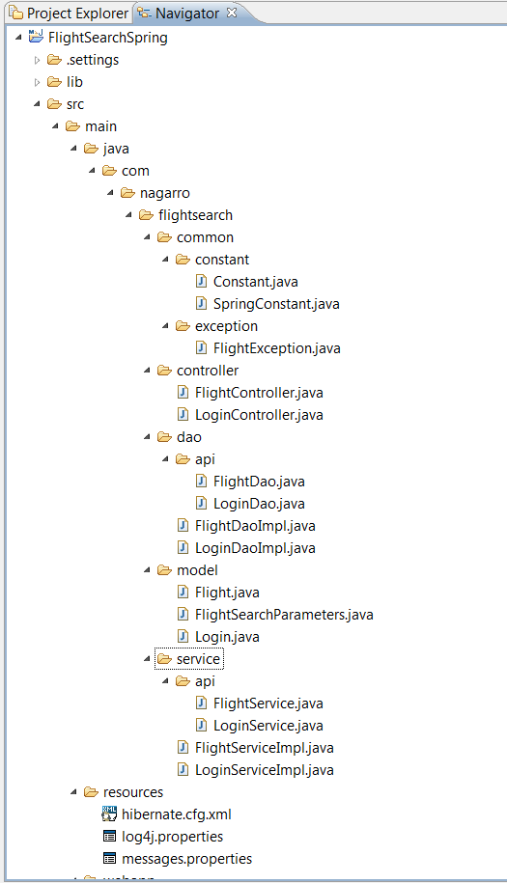

Fig 1 Project Hierarchy

Fig 2 Website Structure

A-3 Design Diagram

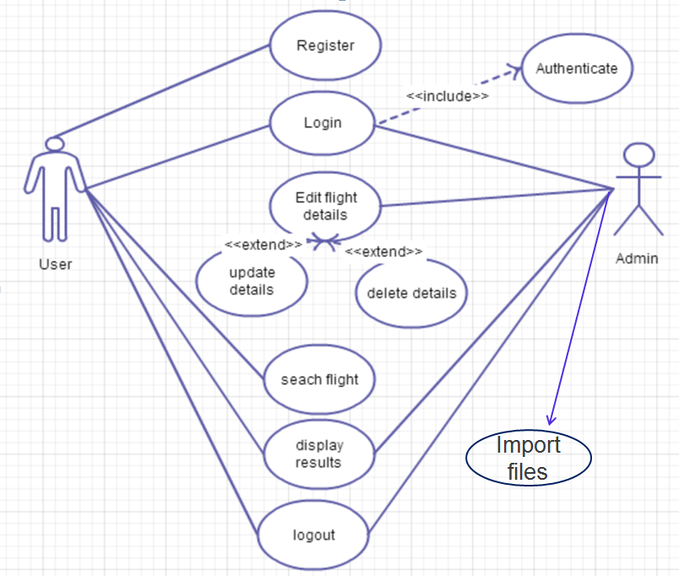

Fig 3 Use Case Diagram

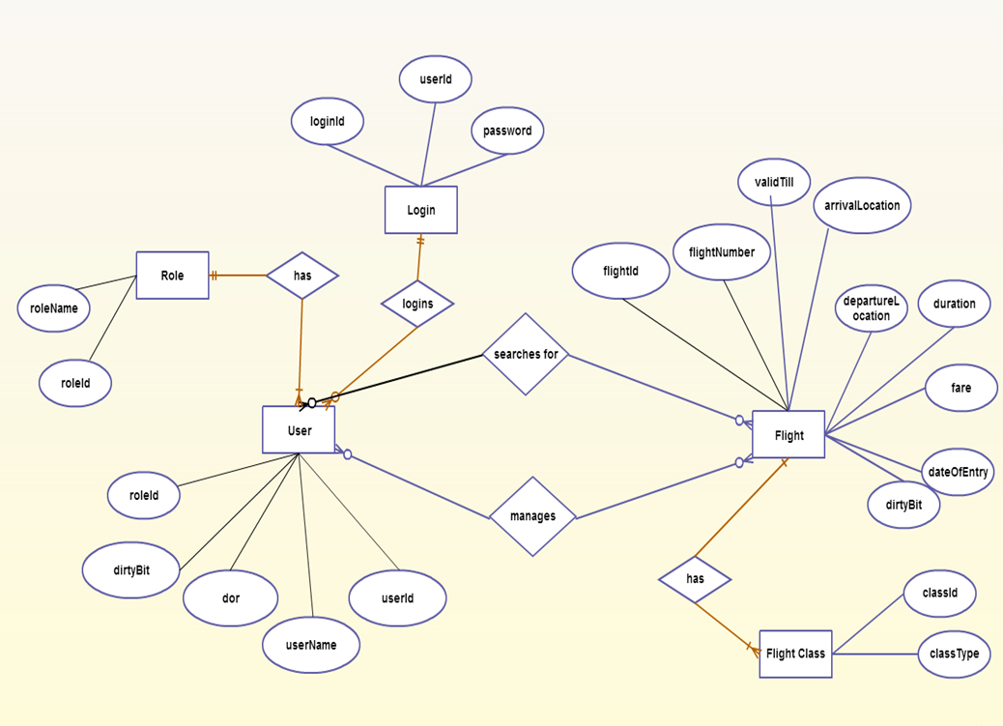
Fig 4 ERD

Fig 5 Database Diagram

A-4 Data Flow Diagrams

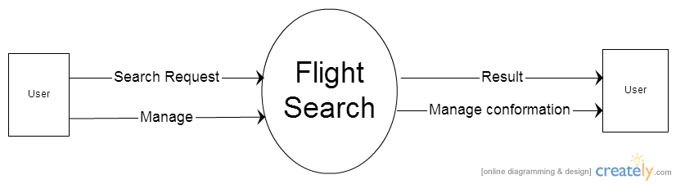
Fig 6 CFD

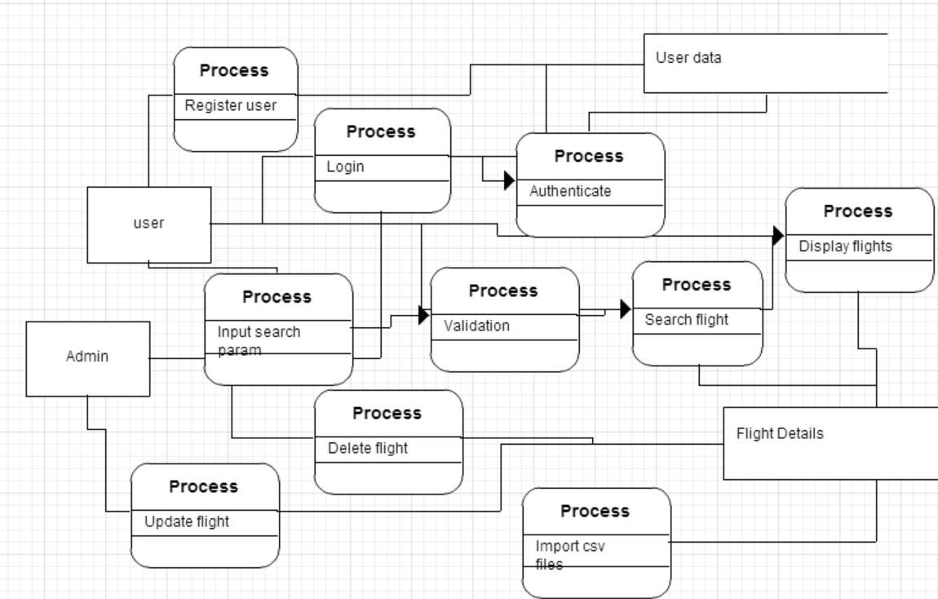
Fig 7 DFD

A5 Process Model
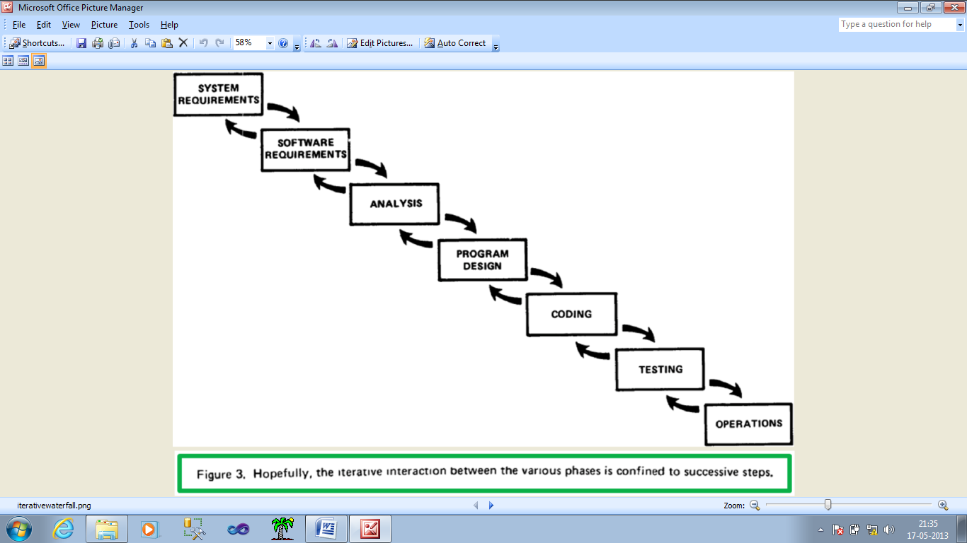
Fig 8 Process Model
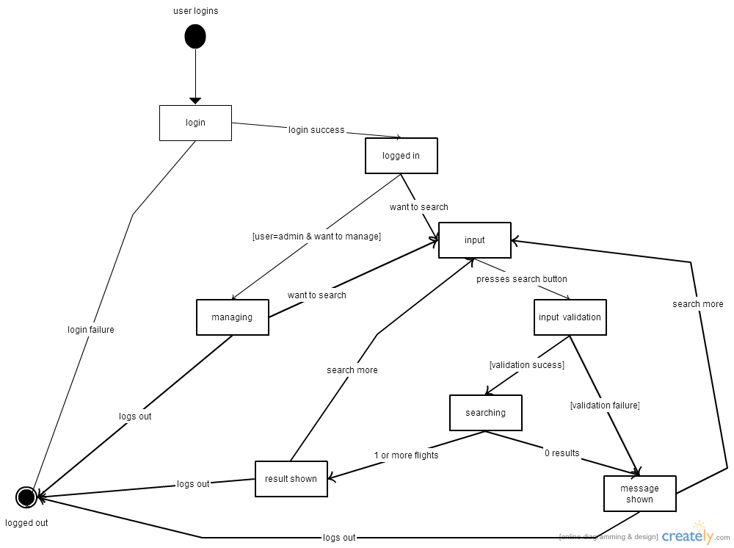Fig 9 State Transition Diagram
A-6 Input Output Design Layout

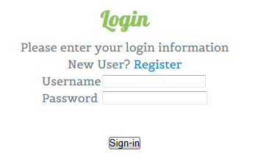
Fig 10 Login Page

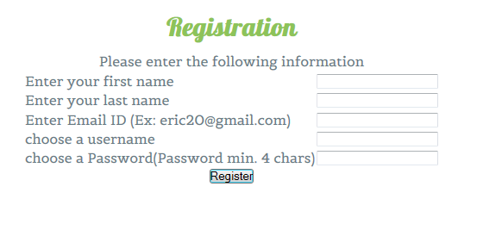

Fig 11 Registration Page

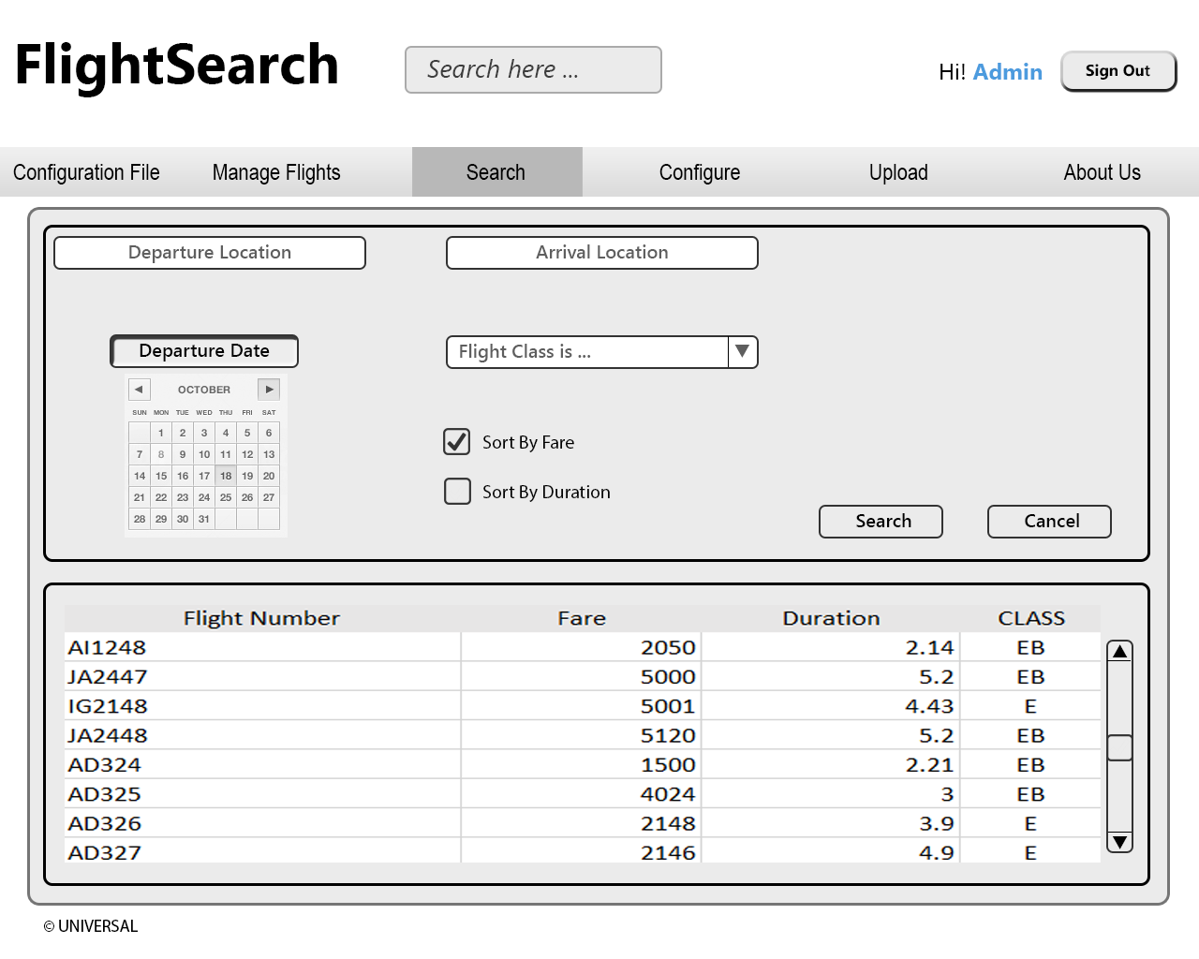

Fig 12 Flight Search

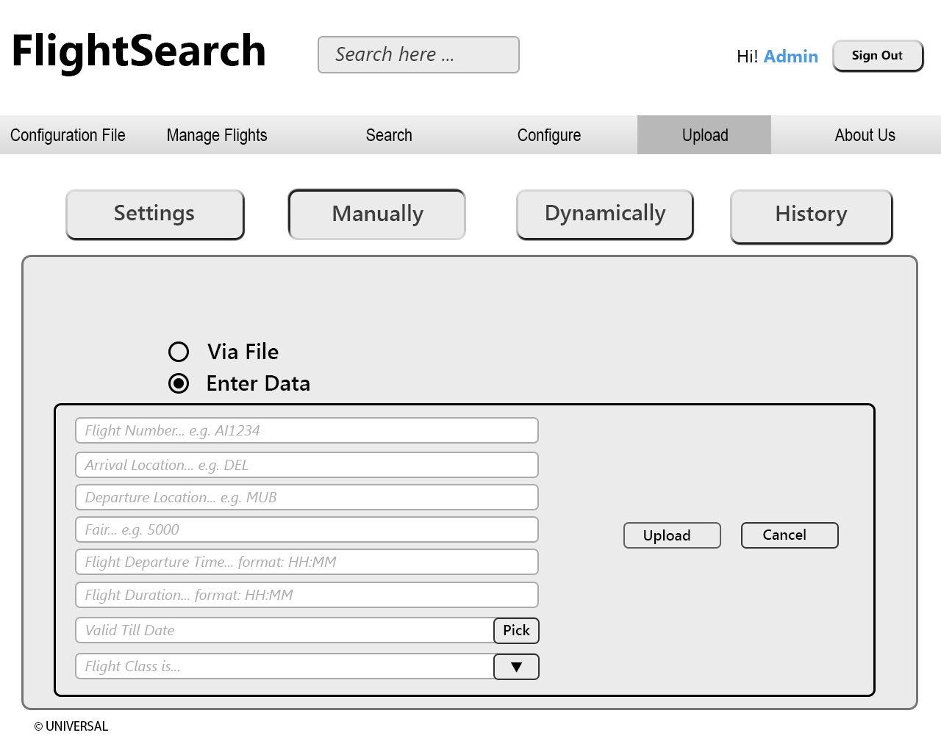

Fig 13 Upload Manually

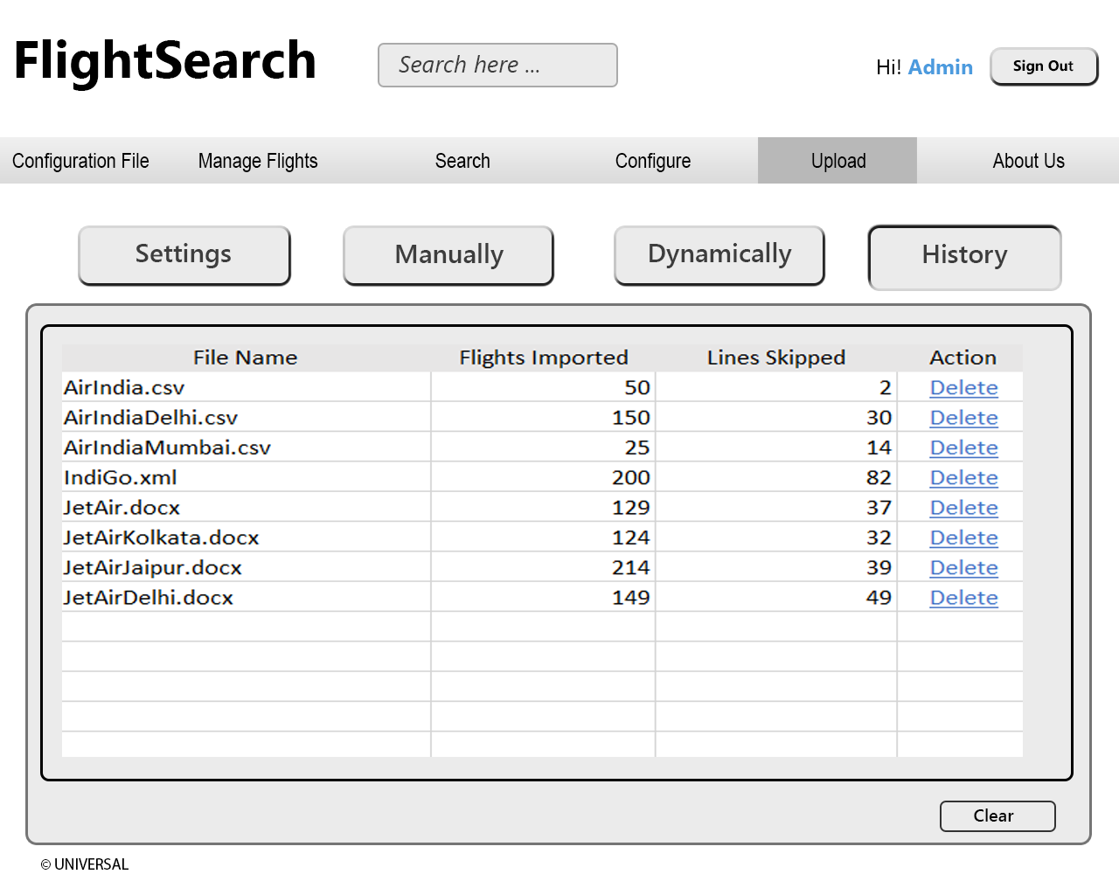

Fig15 Upload History

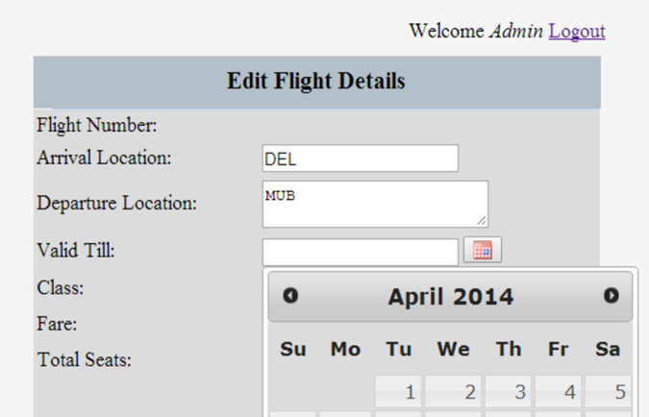
Fig 16 Edit Flight Details
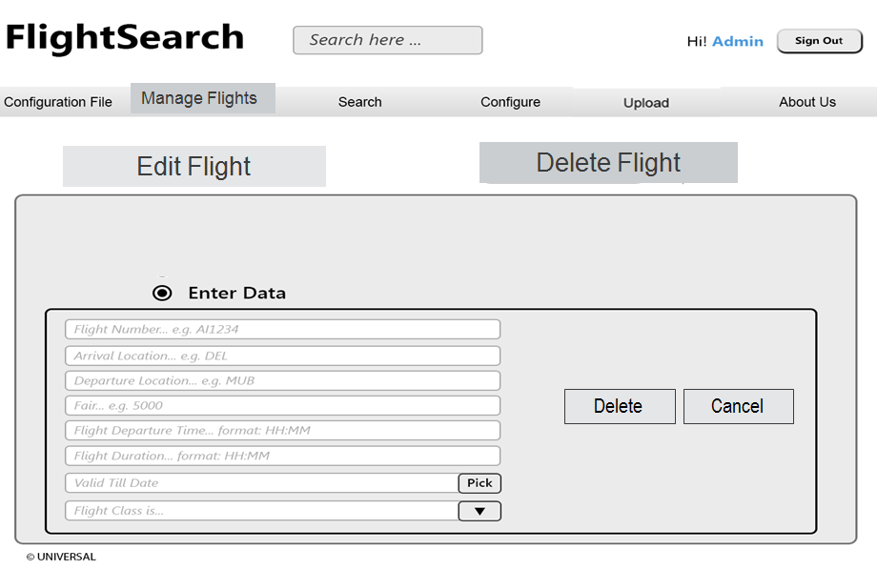Fig 17 Delete Flight
A-7 List of figures and tables
LIST OF FIGURES
Figure Number | Description | Page No.
1 | Project Hierarchy
2 | Website Structure
3 | Use Case Diagram
4 | ERD
5 | Database Diagram
6 | CFD
7 | DFD
8 | Process Model
9 | State Transition Diagram
10 | Login Page
11 | Registration Page
12 | Flight Search
13 | Upload Manually
14 | Upload Dynamically
15 | Upload History
16 | Edit Flight Details
17 | Delete Flight

LIST OF TABLES
Table No. | Description | Page No.
2.1 | Software Requirements
2.2 | Hardware Requirements
2.3 | Client Configuration
3.1 | Flight Table
3.2 | Role Table
3.3 | History Table
3.4 | Use Case Description(Login)
3.5 | Use Case Description(Registration)
3.6 | Use Case Description(Search)
3.7 | Use Case Description(Upload file)
3.8 | Use Case Description(Manage Flights)
3.9 | Use Case Description(Display Result)
4.1 | Unit testing and test cases
4.2 | Integration testing and test cases
4.3 | Functional testing and test cases
4.4 | Non-functional Testing and test cases
4.5 | Unit testing report
4.6 | Integration testing report
4.7 | Functional testing report
4.8 | Non-functional testing report

